
Services at St Mary’s, Berrow
and St Bridget’s Brean
Holy Week and Easter 2026

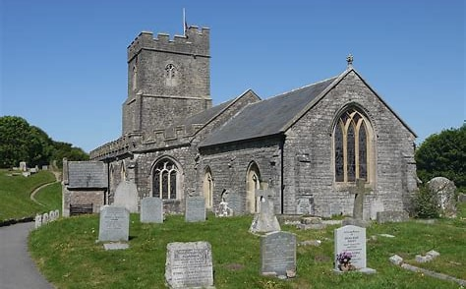
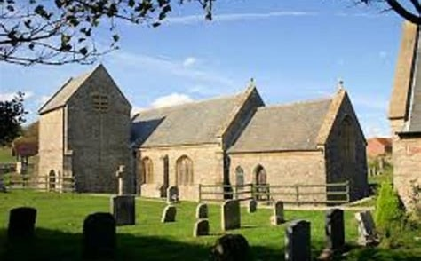
Sunday 29th March
10.30am Benefice Holy Communion St Mary’s Berrow
Monday 30th March
7 pm Licensing of Rev Robyn Golden-Hann, St Mary’s, Berrow
Thursday 2nd April
7 pm Maundy Thursday a service of The Lords Supper with Washing of Feet, St Christopher’s, Lympsham
Good Friday 3rd April
10am Family Activity Morning, St Mary’s, Berrow
2pm An Hour at the Cross – Reflection and Devotion, St Michaels, Brent Knoll
Easter Sunday 5th April
6.15am Easter Sunrise Service, Meet in Brean Down Car Park
10am Benefice Easter Holy Communion, St Mary’s, East Brent
From 30th March the benefice of Berrow and Brean will be joined with the Parish of 3 Saints to create a new benefice.

